INF250 Assignment 2 – Chocolate Factory Image Analysis

Objective: Distinguish between Non-stops and M&Ms using image analysis techniques.

Initial observation
My initial observation of the original image, image (1) in Figure 5, is that I easily can distinguish between Non-stops and M&Ms with my eyes. That is, the Non-Stops are more circular, have a darker shade of color, and they are “flatter”, whilst the M&Ms are more oval and cast more shaddow from the light than the Non-Stops, meaning they stand more out from the background. I also observed that some Non-Stops are broken in half, while all M&Ms are intact.

Pre-Processing
Grayscale conversion and cropping

I am converting the original image to grayscale when it is read in to the .ipynb file. See image (2) in Figure 5. This is to simplify the analyzis of the image, because the image will go from having three colorchannels to one, reducing the data size. Then I crop the image, such that only the chocolates are viewed, essentially removing unnessecairy distractions for the analysis, such as the ruler in the bottom.
Figure 1: Grayscaling and cropping
Thresholding
I then used the Otsu method for thresholding to again convert the image, now to a binary version. This results in image (3) in Figure 5, an image containing only two pixelvalues/gray scales. Inwhich separates the chocolates from the background. Binarizing an image can also remove some noise in the image.
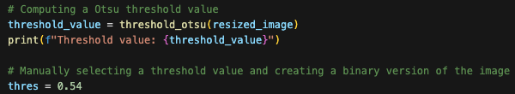
Figure 2: Thresholding
Closing
In the original image we can see that the chocolates, especially the ones colored yellow reflects light. After the preceding preprocessing, this reflection is shown as black spots in the otherwise white chocolates, as seen in image (3) in Figure 5. Therefore, I have applied a closing operation to the image. The closing operation removes such black spots, so they are not mistakenly classified as background during further analysis. The result can be seen in image (4) in Figure 5.
Figure 3: Closing
Opening
The only thing interfering with the actual chocolates and the background now, are some white spots here and there. From the original image it looks like this are crumbles and dust, e.g from the chocolates that are broken in half. To get rid of these spots I have applied the opening operation. This operation fills in the white spots, aka removes them, so they are not classified as chocolate during further analysis. The result can be seen in image (5) in Figure 5.
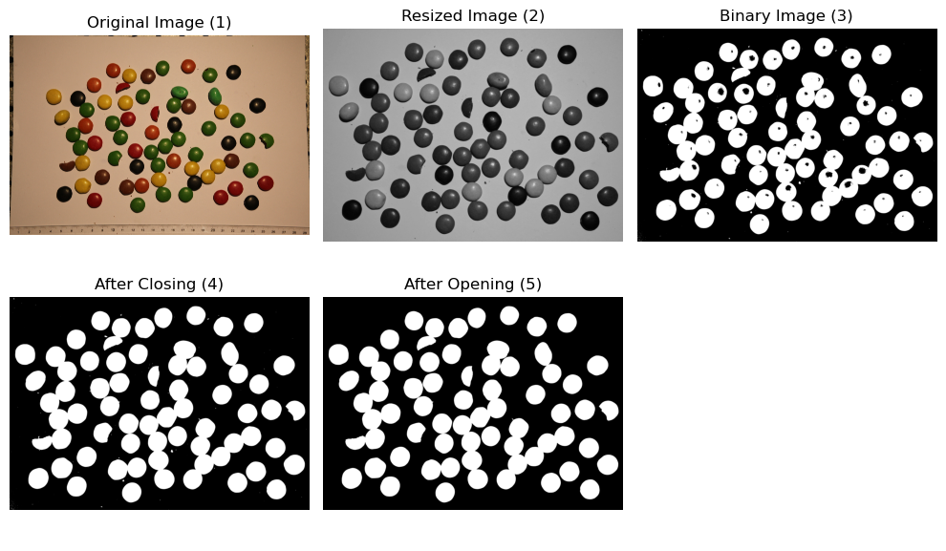
Figure 4: Opening
Figure 5: Resulting images from preprocessing
Feature extraction
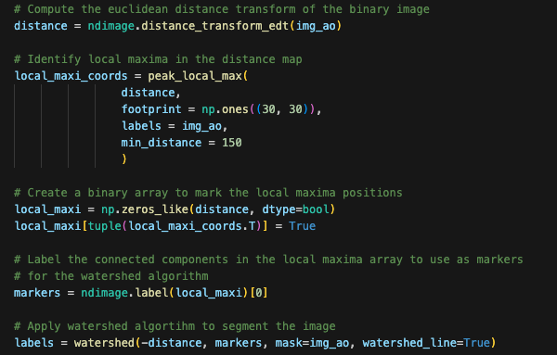
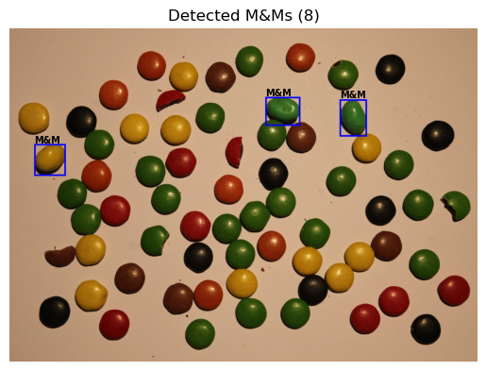
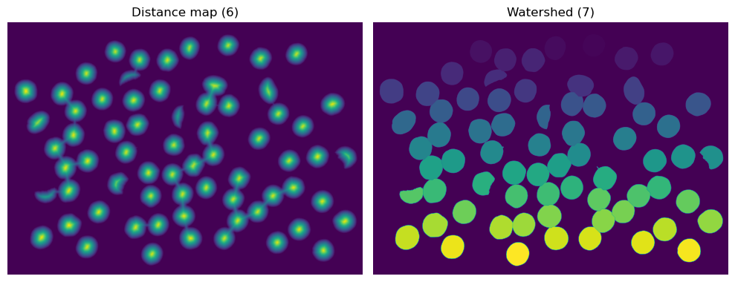
During feature extraction, I first computed a distance map. Then I identified local maximas in the distance map, as markers. Those markers were used when I applied the watershed algorithm to segment the chocolates. The distance map and watershedding can be seen in Figure 8. Further on I used the major axis length property to detect the M&Ms, as seen in Figure 7, resulting in the detection of M&Ms as seen in Figure 9..
Figure 6: Distance mapping and watershedding
Figure 9: Result of disingushing algorithm
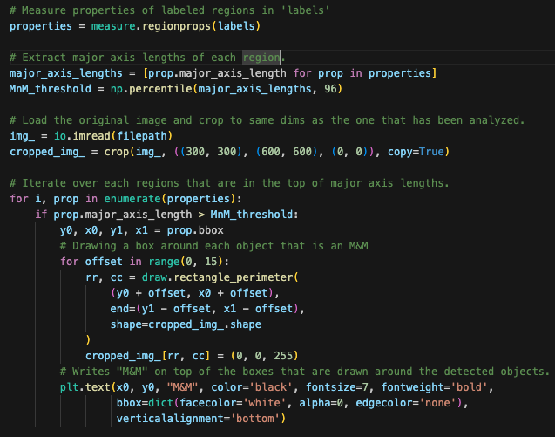
Figure 8: Distance map and watershed
Figure 7: Detecting and highlighting M&Ms

Results & Analysis
My implementation of the chocolate distingushing succeded. During preprocessing, the only problem I came across was the thresholdvalue computed by the skimage built in threshold_otsu method. It did not perform very well. Therefore, I experimented back and forth and found a thresholding value that performed as I wanted. I tried making the preprocessing as few steps as I could, e.g. inverting the binary image in the same step as the original image is binarized.

After having segmented the chocolates with the watershed, I stumbeled my way to successfully separate the the two chocolates. To begin with I used the area property to detect only the M&Ms, but since each individual chocolate have different area independent of what type they are, it failed. Next, I tried with eccentricity, but because some of the Non-Stops were split in half, they got misclassified as M&Ms. The algorithm also failed when I used contour and perimeter, since no chocolate have 100% the same shape nor size. Lastly, I used the major axis length, in which suceeded with distingusihing M&Ms and Non-Stops.

Conclusion
This image analysis successfully identified and distguished the M&Ms from the Non-Stops. Using Otsu thresholding, morophlogical operations and watershed segmentation yielded in clear boundaries for each chocolate, allowing precise classification. By computing the major axis length, the algorithm identified potential M&Ms.

Any future steps and improvements could involve fine-tuning parameters such as the morphlogical thresholds and footprint to handle chocolates close to eachother or various shapes of the chocolate, e.g. the Non-Stops broken in half. Implementing texture analysis could also further improve the algorithm to distingusih the chocolates due to their texture differences.

